Extension Assignment
Breanne Woogman
V00933910
EPHE 310 2020 Dan Geneau

Table of Contents

Unit Plan
Pg. 3-8 Lesson 1 – Dribbling
Pg. 9-12 Lesson 2 – Passing
Pg. 13-16 Lesson 3 – Shooting (Lay-ups)
Pg. 17-20 Lesson 4 – Shooting
Pg. 21-23 Lesson 5 – Defense
Pg. 24-26 Lesson 6 – Game Play

Appendix
Pg. 27 Task Analysis
Pg. 28 UDL Principles
Pg. 29 Teaching assessment – shooting (lesson 4)
Pg. 30 Peer assessment – defense (lesson 5)
Pg. 31 Resources

Lesson 1
Lesson #: 1 of 6  Topic: Dribbling  Grade(s): 6-8 coed  Materials/Resources:  -Basketballs (1 per student)  -Cones (at least 15) | Learning objectives: TSWBAT…  - Dribble a basketball stationary with both their right hand and their left hand  - Crossover the ball from hand to hand  - Dribble the ball while moving around the gym looking for open space  - Understand protecting the ball
Parts of the lesson  Activities:  - Warm-Up: Volcanoes and Ice Creams Cones  - Dribbling  - Dribble Dribble knock-out | Time | Teaching Points
Lesson Description  Warm-up: Volcanoes and Ice Cream Cones  Before students arrive:  -Spread cones sporadically around the entire gym, making sure half are facing up and half are facing down (alternate so that they are mixed)  After students arrive:  -Explain the rules of the game as follows:  - There will be two teams: the volcano team and the ice cream team  - The goal of the volcano team is to have all the cones facing down like a volcano (hold a cone and physically show the cone facing down)  - The goal of the ice cream team is to have all the cones facing up like an ice cream cone (hold cone and physically show the cone facing up)  - Your job is to run around the gym and flip as many cones your way as possible. Once you flip a cone, you have to move on to another one, you cannot guard the cone you just flipped.  - After 2 minutes, the team who has the most cones flipped on their side wins  - Are there any questions? Ok, so if I am on the volcano team, which way am I flipping the cone? And if I am on the ice cream team? Right! And if I flip a cone, can I stand there and guard that one? No I can’t, exactly!  *See Diagram 1.1 at bottom  Skill: Dribbling  -Have each student get a basketball and find space on one half of the gym facing the middle line. The teacher should be standing in the middle of the gym facing the students.  *See Diagram 1.2 at bottom  -Demonstrate athletic position and explain how you have more stability and control when you are low. Have a student volunteer try to push you over while you are standing up straight and then again when you are in athletic position. Have students show you their athletic position.  -Demonstrate to the students the proper way to dribble a basketball, bouncing the ball with the tips of their fingers rather than their palm. -Have the students begin to dribble the ball with their dominant hand in a stationary position, remembering to stay low. --Encourage students to keep their dribble low, ideally below the knee. Explain that this makes it harder for someone to come steal the ball from them. The teacher should be circulating ensuring each student is doing it correctly and helping where needed.  -Have students pause and explain to them the importance of shielding the ball by using a protecting arm.  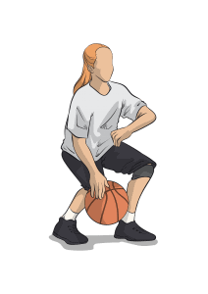  Have students continue to do the stationary dribbling, but now adding the protective arm. As the teacher, you should be circling and can attempt to swipe the ball away from the students, enforcing the protective arm.  -Have students begin to walk around the gym while dribbling, reminding them to keep their head up as to not crash into each other. Tell students they should be looking to get into open space.  -Get students to stop their dribbling and go back to their original position on one side of the gym. Now tell the students to switch hands and practice dribbling with their non-dominant hand. Remind them to stay in athletic position, head up, and arm protecting  -Have students again walk around the gym dribbling with their non-dominant hand. Reinforce head up, look for open space, and protective arm.  -Get students to stop their dribbling and go back to their original position on one side of the gym. Demonstrate a crossover, switching hands with each dribble. Remind them again to stay low in athletic position. Have students try crossovers, the teacher should be circling and helping where needed.  -Have students pause their dribbling to listen to instructions. Instruct students to dribble around the gym, using their dominant hand and crossing over to their non-dominant hand to change direction. Demonstrate what this looks like, reminding students the importance of keeping their head up and protecting the ball. Allow the students to practice.  UDL Checkpoint 8.4  Game: Dribble-Dribble Knock Out  -Have all of the students on one half of the gym.  -Explain the rules of dribble-dribble knockout:  - The teacher will outline a boundary and all the students have to stay within that boundary  - Every player will be dribbling a basketball moving around the space  - You will be trying to knock the ball away from one of the other players  - If your ball goes out of bounds, you are out  - As people get knocked out, the boundaries become smaller  - The goal of the game is to be the last person standing | 2 min  5 min  15 min  9 min | -Split up the children into the two teams (ex. All the children wearing black pants on one side) and send them to opposite sides of the gym. (remind the kids again which team they are on. “This side is the volcano team! This side is the ice cream team!”)  -Begin the game by counting down. Announce how much time is left at 1 minute, 30 seconds, and then count down from 10.  -Have students go back to their sides and count the cones to determine a winner. (note: know how many cones are in play so you only need to count one side. Incorporates math into PE and speeds up the process.)  -Reset and play again! (can switch teams so the ice cream cone is now the volcano team and vice versa).  -Have class help clean up cones  -Safety: Remind children to keep their head up so they do not trip on cones or bump into classmates. Show a demonstration of this.  -Adaptive scoring: if one team is winning, give the other team an advantage by having more of the cones flipped on their side at the beginning  Modifications:  - Can make the amount of time shorter or longer  - Determine how many cones you want to use depending on how many students you have. If there aren’t enough cones, students will not know where to go. If too many cones, students will not move as much and most likely only stay in one section. You want to have at least one cone for each student plus a few extra.  - Could combine this game with freeze dance by playing music and stopping the music to have them freeze in place  - If you are having trouble getting the students to stop dribbling while talking, come up with a strategy. Examples of this could be having the kids stop and put their balls on the ground with their foot on it or holding the ball on top of their head.  - Show an example of slapping the ball with your palm and explain that this is not correct.  -remind students to push themselves and that it is ok to lose the ball. Remind them to keep their head up while dribbling.  - You can demonstrate by having one student try to take the ball from you.  -Safety: When students are dribbling around the gym, remind them to keep their head up and look around so they do not bump into each other.  -most students will have trouble with this; reassure them that it is okay to lose the ball and to do the best they can.  -for students who want more of a challenge, you can have them doing through-the -legs or behind the back crossovers.  -Children who want more of a challenge can run. Students struggling can walk.  -Typically the first boundary would be half court  -If this is too difficult for students, can change the rules to allow them to have a certain amount of “pick ups” (picking up the ball)  -A couple different options for what students can do when they get out:  - Can have two games going on each side of the gym so if they get knocked out of one game, they can join the other  - Can have students along the perimeters trying to swipe away other player’s balls  - Can have students go to the other side of the gym and practice their dribbling/shooting  - Can have students complete a task “punishment” before returning to the game (ex. Go make 5 shots then you can return)
Closure  -Wrap up by congratulating each student on a job well done. Remind them that this is new and that it is okay to make mistakes. High-five each student on the way out.  Psychomotor: Learn the proper way to dribble a basketball, get into athletic stance  Cognitive: Dribble a ball while keeping their head on a swivel, be looking to get into open space, multitasking (dribbling, moving, protecting)  Affective: Become confident in their dribbling. Learning the importance of practice. Students could become frustrated if they cannot multitask of keep losing the ball. Competitive aspect of game. | 1 min
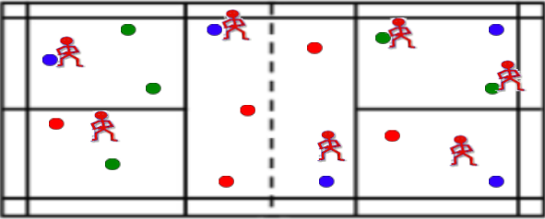Diagram 1.1
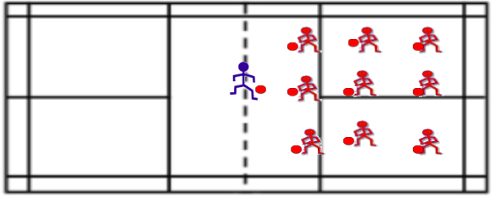Diagram 1.2

Lesson 2
Lesson #: 2 of 6  Topic: Passing  Grade(s): 6-8 coed  Materials/Resources:  -Basketballs (1 for every 2 students)  -Pinnies (3 different colors) | Learning objectives: TSWBAT…  - Understand the importance of teamwork  - Bounce pass, chest pass, and overhead pass
Parts of the lesson  Activities:  - Warm-up game: Octopus  - Partner Passing  - Basketball passing game | Time | Teaching Points
Lesson Description  Warm-up: Octopus  -one student is the “octopus” and stands in the center of the gym  -everyone else stands on the end line facing the “octopus”  -When ready, the teacher yells out “octopus” and all the students try to run to the other end of the gym  -The octopus tries to tag the students running by  -if a student gets tagged, they stop where they are and become “seaweed”. They cannot move their feet but they can try to tag people by reaching for them.  -repeat this until one student remains  Skill: Partner Passing  -Have each student find a partner and grab a ball  -Have the students stand on opposite lines facing each other  *See Diagram 2.1 at bottom  -Demonstrate the bounce pass. Show how you should be low, starting with the ball at your chest, then stepping into the pass. You want to try to bounce it closer to your partner, about 3-quarters of the way between you and your target, aiming for your partner’s chest. The partner should be ready to receive by having their hands show a target  -Have students practice with their partners for about 2 minutes  -Next, demonstrate the chest pass. Show how to step into the pass, having the ball at your chest and aiming for your partner’s chest. The partner should be ready to receive by having their hands show a target.  -Have students practice this with their partners for about 2 minutes  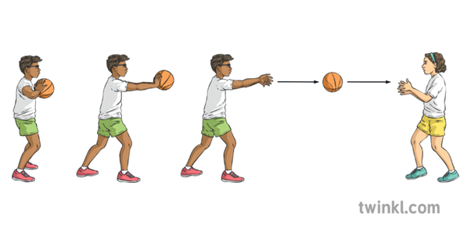  -Lastly, demonstrate the overhead pass. Show how to step into the pass, having the ball above the head but not behind the neck like a soccer throw. They should be aiming for their partner’s chest and the partner should be ready to receive by having their hands show a target  -have students practice this with their partners for about 2 minutes  Game: Basketball passing game  -Using the two smaller courts, divide students into 4 teams.  *See Diagram 2.2 at bottom  -Explain the rules of the game:  - The goal of the game is to get the ball to the other side  - There is no dribbling, if you have the ball you are frozen in place and can only pivot  - Teams must pass the ball to each other in order to try to get to the other side  - The other team is playing defense and trying to intercept the ball  - If a team makes it past the other team’s line, they get a point. The other team then starts with the ball from the line  UDL Checkpoint 8.3 | 7 min  12 minutes  (2 min for each explanation, 2 min for each practice)  10 min | -allows students to warm up their bodies and get some energy out, as they will be more stationary when learning passing  -safety: make sure students are lightly tagging. Remind them to be honest if they get tagged  -modification: can call “jail break” and all the seaweed are free to join the game again  -modification: If the octopus is having trouble tagging people:  - Add another octopus  - Teacher helps tag people  - End the game early  - Free the seaweed and let them tag people as well  -Can have students pick own partners or partner them up yourself (ex. Find someone born in the same month as you)\  -if there is an odd number, can be a group of 3 or the teacher can partner with the student  -Safety: emphasize the target hands as to ensure no student gets hit in the face with a ball  -teacher should be circulating and helping correct form where needed  -modifications: can have students move closer together if they are struggling and farther apart if it is too easy for them  -students may need to take a step back for this throw, remind them they can do this.  -depending on class size, you can play full court or two smaller games using half the gym. Teams should be kept smaller (5 players) so more students have the opportunity to touch the ball.  -demonstrate what pivoting is and have students try it with both feet  -Can have the teams switch who they are playing halfway through  -If you notice students are not involved, make it a rule that each teammate has to touch the ball to get a point  -Could make it a rule that each pass (overhead, chest, bounce) has to be used to score a point
Closure:  Wrap up by congratulating the class on a job well done. Tell the class they can practice this at home with siblings or parents. High-five each student on the way out.  Psychomotor: Learning the three ways to pass, running, defense  Cognitive: Aiming, putting force behind a pass, getting into open space, teamwork  Affective: Teamwork, working with a partner, distance between partners based on comfort level, making sure all students are included in the game | 1 min
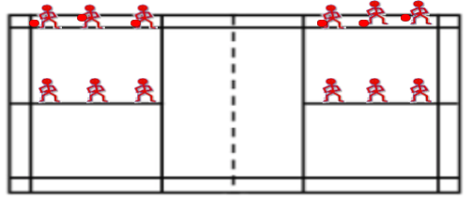Diagram 2.1
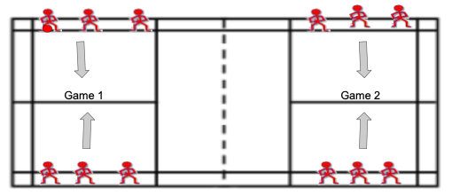Diagram 2.2

Lesson 3
Lesson #: 3 of 6  Topic: Shooting  Grade(s): 6-8 coed  Materials/Resources:  -Basketballs (1 per 3 students)  -basketball hoops  -cones (one per hoop) | Learning objectives: TSWBAT…  - Demonstrate the proper footwork of a lay-up
Parts of the lesson  Activities:  - Warm-up game:  - Lay-ups  - Bingo shooting | Time | Teaching Points
Lesson Description  Warm-up: Electric Fence  -have two students volunteer to be on the fence. Send them to stand on the two chosen lines. Have all the other students start on the baseline  *See Diagram 3.1 at bottom  -explain the rules:  - The goal is to get to the other side without getting tagged.  - The people who are “it” can only move on their line. They are stuck on the fence  - The teacher will call “electric fence” and the students will try to run to the other side of the gym.  - If a student gets tagged, they join the person on the fence.  - This continues until there is one student left  Skill: Lay-ups  -Have students sit around the three point line facing the hoop.  -demonstrate the proper footwork for a right-hand lay up  - Right foot, left foot, up  - Explain that this is not considered travelling  - Explain that they should be aiming for the square to make the basket  -split the class in half and have them start on opposite sides of the center line  -Give balls to the people at the front of the lines  -have students dribble to the basket and practice a lay-up. Have them rebound the ball and pass it to the next person in the opposite line.  *See Diagram 3.2 at bottom  -Repeat this circuit until all students have gone at least 6 times.  -Tell the students to pause and have them switch to left hand lay-ups  - Left foot, right foot, up  -Have the lines switch direction and continue the circuit again  UDL Checkpoint 3.3  Game: Bingo Shooting  -split up class into teams of 4 and send them to side hoops  -have them start by lining up on the right elbow facing the net.  -each team gets 2 balls.  -explain rules of the game:  - Students are going to take turns doing a lay-up, rebounding their ball, and passing it to the next person in line.  - If the student scores, they get a letter. The goal is to try to spell “BINGO”.  - If the student misses, they quickly rebound the ball and pass it to their teammate.  - Once a team gets BINGO, they yell out “bingo” and get a point. Each team will leave the balls at their hoops and run to the next hoop (counterclockwise)  *See Diagram 3.3 at bottom  - Once a team gets 3 points, the game is over. The losing teams can complete some type of penalty (ex. 10 push ups)  -After doing right hand lay-ups, have students do the same thing with left hand lay-ups by starting on the left elbow. | 10 min  10 min  10 min | -if a student is taking too long to run past, can count down  -if one line has lots of students and another doesn’t, you can move students to even it out  -if a student is having trouble tagging, you can join them on the line.  -safety: remind students to be gentle when tagging, especially close to the walls.  -for students who want more of a challenge, have them try underhand lay-ups  -challenge advanced students to take long strides with their lay-up  -if students are struggling, put a cone where they can start their lay-up  -correct students who are travelling. If students are struggling you can pull them aside and work 1-on-1 with them  *can use side hoops if you have a larger class so they get more reps in  -can split them up randomly or strategically based on what you have observed.  -Check for student understanding:  - Which hoop are you going to next? (counterclockwise)  - When you switch hoops, when do you start again? (right away)  - What do you do when you get BINGO? (scream “BINGO” and run to the next hoop)  - Do you bring the basketballs with you? (no, leave them at your hoop)  -would recommend doing a practice round first  -modifications: can make the starting spot closer/farther depending on skill level. Can put a cone to make it clearer.
Closure
Wrap up the class by congratulating the students on a job well done. Let them know that next class they will practice this more as well as learn proper shooting technique. High-five each student on the way out.

Psychomotor: running, shooting, hopping
Cognitive: performing the proper footwork, knowing when to start your lay-up, being fast but also precise.
Affective: Teamwork, may feel pressured by team and could be discouraged if they aren’t scoring, may find the footwork difficult and get frustrated, understanding the importance of practice

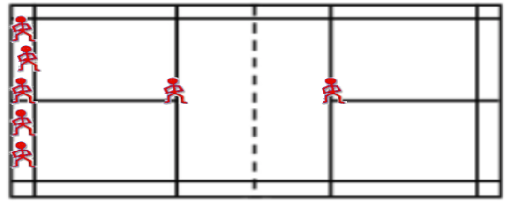Diagram 3.1
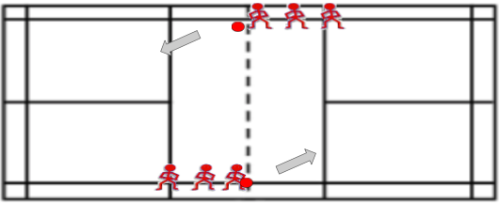Diagram 3.2
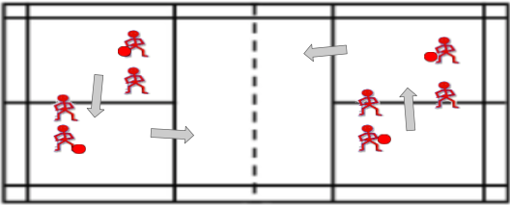Diagram 3.3

Lesson 4
Lesson #: 4 of 6  Topic: Shooting  Grade(s): 6-8 coed  Materials/Resources:  -Basketballs (one per student)  -Basketball hoops  -Gym | Learning objectives: TSWBAT…  - Demonstrate proper shooting form  - Aim the basketball  - Understand the importance of form while still moving quickly
Parts of the lesson  Activities:  - Warm-up: Cat and Mouse  - Line shooting  - Video game shooting  - Bump | Time | Teaching Points
Lesson Description  Warm-up: Cat and Mouse  -Partner up the students and have them spread out around the gym  -Pick one pair to start as the cat and mouse. Assign each role to one student.  -Have the rest of the students lie down on their stomachs next to their partner  -The goal of the cat is to chase the mouse and tag them. If the cat successfully tags the mouse, they switch roles and the mouse then chases the cat.  -In order for the mouse to be safe, they must lie down next to one of the pairs. The person on the side that the mouse does not lie down on must get up and become the new mouse.  -If teacher yells “switch” the cat and mouse change roles  Skill: Line Shooting  -Have students line up on the base line and face the teacher standing in the middle  -Demonstrate proper shooting form. Emphasize key components:  - Athletic position  - Hand positioning on ball (one hand is shooting hand and the other is just for guiding)  - Explain BEEF: balance, eyes, elbows, follow-through. Go through each step individually, then show the fluid motion  -Have each student get a ball and find a spot around the gym on a line. Make sure they are spaced out  -Tell students to practice their shooting, aiming to hit the line in front of them. Make sure they are considering “beef”  UDL Checkpoint 5.3  Game: Video Game Shooting  -While students are practicing shooting and/or getting a water break, set up cones around the gym.  *See Diagram 4.1 at bottom  -Explain the game:  - There are cones set up at each hoop. Students must go in order and score a basket from each cone before progressing to the next hoop  - If students complete the whole circuit, they receive a point and can keep going  -Encourage students to go fast, but focus on their form and timing. They do not want to shoot at the same time as their classmates and bump the balls.  Game 2: Bump  -Have students line up at one main hoop starting at the free throw line.  -Give one ball to the person at the front of the line and one ball to the person behind them  -Explain the rules of the game:  - Two people are shooting at a time. If the person behind you scores before you do, you are out.  - The first shot must be from the free throw line, but after that the student can shoot from wherever they like  - The student behind can not shoot until the person in front of them shoots first  - When you score, quickly grab your ball and pass it to the next person in line  - You can bump your classmates ball to give yourself more time to score. Can only do this if it is not in their hands  - The last person standing wins | 6 min  3 min  5 min  10 min  5 min | -can have students pick their own partners or just partner them up by whoever is next to them. The partners will not stay the same for very long, and this is something you can tell to students  -if there is an odd number teacher will have to participate  -Walk through an example of this so students understand  -call “switch” if the cat has been the cat for a long time  -teacher is to fill out the teacher shooting assessment found in appendix  -space them out enough so they have space to shoot the ball  -Teacher should be circulating and correcting form where needed  -Modification: If a student is shooting with both hands, have them put their guiding hand behind their back and really focus on shooting with just their dominant hand  -set up distance of cones based on skill level of class. Each progression should be further than the last as to give more of a challenge. At highest level, cones would be at three point line  -if a student is feeling frustrated because they can’t make a shot, allow them to move on to a different spot even if they didn’t make it.  -You can use all 6 hoops if there is space, or just the 4 side hoops  -Depending on class size, you can start students at different hoops so they won’t be too crowded  -safety: remind students to be aware of balls flying  -When students get out, have them shooting around on the other side of the gym or give them another game/activity to do  -Modifications:  - If you do not want students to be out, you can have two games going on at the same time. If a student gets out on one side, they join the other  - Another option is that if a student gets out, they have to go to the other side of the gym and make 5 shots before rejoining the game  - Can have no bumping to eliminate violence/being picked on  - To make it harder: can have it so if they miss their second shot, they are out  -Safety: beware of flying balls. Ensure you are not bumping another student’s ball if it is in their hands.
Closure  Wrap up the class by congratulating students on a job well done. Encourage them to practice at home if they have access to a basketball and a hoop. High-five each student on the way out.  Psychomotor: Athletic position, proper shooting form, speed while maintaining form.  Cognitive: Finding balance between proper form and speed, aiming, how much power to put behind the ball  Affective: Students could become frustrated if they are not scoring. Students may feel picked on during bump (see adaptations to avoid this). Understanding the importance of practice and being proud of new accomplishments (ex. Making a shot they couldn’t before) | 1 min
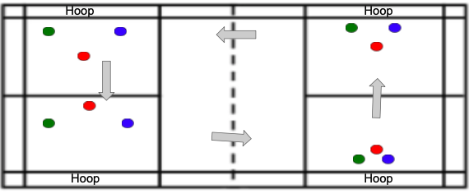Diagram 4.1

Lesson 5
Lesson #: 5 of 6  Topic: Defense  Grade(s): 6-8 coed  Materials/Resources:  -Basketballs (1 for every 2 students)  -Pinnies (3 colors)  -2 Dodgeballs (ball for handball)  -4 Soccer nets | Learning objectives: TSWBAT…  - Have proper defense stance  - Understand the importance of defense  - Shuffle and keep positioning between the offensive player and the net
Parts of the lesson  Activities:  - Warm-up: knee tag  - Shuffling cross court  - Handball | Time | Teaching Points
Lesson Description  Warm-up: Knee tag  -Partner up students and have them find a space in the gym  -explain the rules and demonstrate with a student:  - The goal of the game is to try to tag your partner’s knees  - You are trying to block that person from tagging your knees  - If you tag your partner’s knee you get a point  Skill: Cross-court shuffling  -In the same partners, split the class in half and have them start on opposite corners of the gym  -Give one ball to each set of partners  -Have one partner dribble diagonally, switching hands whenever they get to the middle line or sideline  -The other partner is defending them by side-shuffling and positioning themselves between the player and the net.  *See Diagram 5.1 at bottom  -once the pair get to the other side, they switch roles and join the line on the opposite side  -students can go once the pair in front of them makes their first crossover.  -Once they have been doing this for a while, can have them switch sides so they are starting from the left side instead.  -Have students fill out peer assessment (Found in Appendix)  UDL Checkpoint 6.3  Game: Handball  -Split the class into 4 teams and send them to the side hoops. Give pinnies.  -Explain the rules of handball:  - The goal is to have your team score on the other team by throwing the ball into their net  - Each team has 1 goalie that can stand in the basketball key, no one else is allowed inside the key  - If you are holding the ball, you are allowed one step, and then you can only pivot.  - Each student picks a “check” from the other team who they will defend when their team does not have the ball.  - The team with the most points when time is up wins. | 4 min  10 min  15 min | -can half them choose own partners or choose partners yourself (ex. Find a partner wearing the same color shirt as you)  -if there is an odd number, either the teacher can participate or can have 1 group of 3  -Can have them switch partners  -Do a demonstration of proper defensive form:  - Low, athletic position  - Hands; one high one low  - Shuffling without crossing feet  -Modification: To make it more “game -like”, once the pair reaches the three-point line, it becomes a live 1 on 1 (offense tries to score, defense tries to stop them)  -could also do 2 teams and use the full gym or 3 teams with a rotation depending on how many students you have  -can put cones around the key to make it more clear  -Halfway through I would switch who is playing who (ex. If team 1 is playing team 2 and team 3 is playing team 4, team 1 would then play team 3 and team 2 would play team 4)  -If students are not participating, can make a rule that everyone needs to touch the ball in order to take a shot.  -Safety: tell students to aim down as to not hit the goalie in the face
Closure  Wrap up class by congratulating students on a job well done. Tell students that next class they will get to try out a real basketball game. High-five each student on the way out.  Psychomotor: athletic position and staying low, shuffling, dribbling  Cognitive: Remembering to stay in between the offense and the net, looking for open space to get away from defender  Affective: students could become frustrated if they can’t get open, teamwork, could be painful staying low if students are not used to it. | 1 min
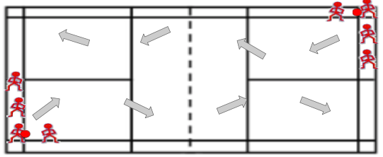Diagram 5.1

Lesson 6
Lesson #: 6 of 6  Topic: Game  Grade(s): 6-8 coed  Materials/Resources:  -Basketballs (1-2 balls)  -Pinnies (3 colors)  -Basketball hoops | Learning objectives: TSWBAT…  - Understand the rules of a proper basketball game  - Demonstrate all the skills learned throughout the unit: dribbling, passing, shooting, defense  - Understand the importance of teamwork
Parts of the lesson  Activities:  - Warm-Up: dynamic stretching  - Explanation of rules/boundaries  - Basketball Game | Time | Teaching Points
Lesson Description  Warm-up: Dynamic stretching  -Have the students make 4 lines on the base line  -Have them do the following exercises to the center line and back:  - Jog  - Skipping  - High knees  - Butt kicks  - Open the gate (close the gate back)  - Lunges (with twist)  - Squats  - Sprint  Skill: Explanation of rules/boundaries  -split the class into 4 teams  -explain the rules and boundaries for a basketball game:  - Make clear the out lines  - Travelling, double dribble, fouling  -explain inbounding the ball both after a basket and when the ball goes out of bounds  UDL Checkpoint 3.1  Game: Basketball Game  -Help students pick a check from the other team  -start both games with a jump ball  -have each team play each team (5-minute games with time in between for water breaks) | 6 min  5 min  18 min | -can make more or less lines depending on amount of students (have about 5 students per line)  -can add other exercises depending on class and what stretch you want the students to complete  -can have the students do the exercise to the middle line and jog back  -try to split based on skill level so teams are even  -try to make teams of 5, amount of teams may change depending on class size. Can have smaller teams too (4 on 4 or 3 on 3)  -use side hoops so you can have 2 games going at once  -can adjust rules depending on skill level (ex. Double dribbles are ok, can take one step, etc.)  -can implement rules if students are not getting passed to (ex. Must pass to each student)  -Stand in the middle and watch both games; help make foul calls and out balls.  - This can be difficult, but I think it is better than playing one game as more students are able to be involved  -can have subs but make sure to rotate them very frequently (every 2 minutes)
Closure  Wrap-up by congratulating the students on a job well done. Thank the students for all the hard work they have put into the unit. Remind them that practice makes perfect. High-five each student on the way out.  Psychomotor: running, jumping, athletic position, shooting, dribbling, passing  Cognitive: understanding and performing the rules, putting together all skills learned, transitioning from offense and defense  Affective: working on a team, could feel overwhelmed and nervous for real game play. | 1 min

Appendix

Task analysis
Developmental Task Analysis: Lesson 1 – Dribbling
Stage 1: Students are in athletic position, bouncing the ball anyway they see fit, looking at ball
Stage 2: Students are in athletic position, dribbling the ball with their fingertips, looking at ball
Stage 3: Students are in athletic position, dribbling the ball with their fingertips, looking around for open space
Stage 4: Students are in athletic position, dribbling the ball with their fingertips, looking around for open space, with protecting arm
Stage 5: Students are in athletic position, dribbling the ball with their fingertips, looking around for open space, with protecting arm, keeping dribble hard and low to the ground (below knee).
Systematic Task Analysis: Lesson 4 – Shooting
Step 1: Get into a low, athletic stance
Step 2: Put dominant hand underneath ball, resting on fingertips, and non-dominant hand resting on the side of the ball
Step 3: Tuck elbow in and hold ball in front of face, eyes looking over the ball at the hoop
Step 4: Extend body and arm upwards, straight towards the basket
Step 5: Release ball at highest point, rolling off fingers (side hand should not impact shot)
Step 6: Follow-through: hand should be relaxed, fingers pointed at rim, finishing high. Hold until ball hits rim.

UDL Principles
Lesson 1: Checkpoint 8.4 – Increase mastery-oriented feedback.
While students are dribbling, the teacher is circling and giving feedback to individual students. The feedback given is individualized allowing the students to adjust and show improvement from where they started, rather than comparing them to others. The teacher emphasizes the role of practice and helps give students the critiques they need to be successful.
Lesson 2: Checkpoint 8.3 – Foster collaboration and community
Students are given multiple opportunities to engage with peers. First, students are able to work in partners to develop their passing skills, allowing opportunity to learn from each other. Later on, students are able to work on a team and compete towards the same goal. Students are able to learn the importance of teamwork and experience the benefits of learning from each other.
Lesson 3: Checkpoint 3.3 – Guide information processing and visualization
The teacher is breaking down the lay-up into steps in order for students to be able to see each movement in the sequential process. Students who are struggling can have individual help where they focus on just the footwork and then add in the ball, allowing for scaffolding. The process can be broken up into steps to help students process the movement.
Lesson 4: Checkpoint 5.3 – Build fluencies with graduated levels of support for practice and performance
Students are first shown shooting form from the teacher and are then able to try it themselves. They are surrounded by their peers and are therefore able to watch the technique from different people. The teacher is circling and providing differentiated feedback to each student dependant on their skill level and what they can improve on.
Lesson 5: Checkpoint 6.3 – Facilitate managing information and resources
Students have the opportunity to complete a peer assessment, in which a checklist is provided and there is space for commentary. This forces the students to be observant of their partner and how the skills should look, as well as reflect on their own form.
Lesson 6: Checkpoint 3.1 – Activate or supply background knowledge
The teacher provides the rules and regulations in a formal game of basketball. The teacher demonstrates specific rules such as traveling, double dribbling, and fouling to provide examples. The teacher explains how each of the skills learned throughout the lesson is useful to the game.

Shooting Form – Teacher Assessment Block______

Grading  Award students a check mark if they meet the shooting cues. Award students an X if they are not yet meeting the shooting cues. Make comments of observations and areas of improvement. | Shooting Cues:  B: Balance – Athletic position, feet are shoulder width apart  E: Eyes – Ball is positioned just below eyesight; looking at basket (target)  E: Elbows – Elbow is at a 90-degree angle underneath ball  F: Follow-through – Arm becomes straight and wrist is pointed downwards; holds until ball hits rim

Student Name | B | E | E | F | Comments

Name ________ Defensive Positioning – Peer Assessment Block____

Grading: If criteria is met, give them a checkmark in the corresponding number box. If criteria is not met, make notes for improvement.
Defensive Checklist
- Athletic position: low stance, knees bent, head up.
- Hand positioning: One arm high, one arm low. Switches with offensive player
- Movement: Player shuffles with offensive player, does NOT cross over feet
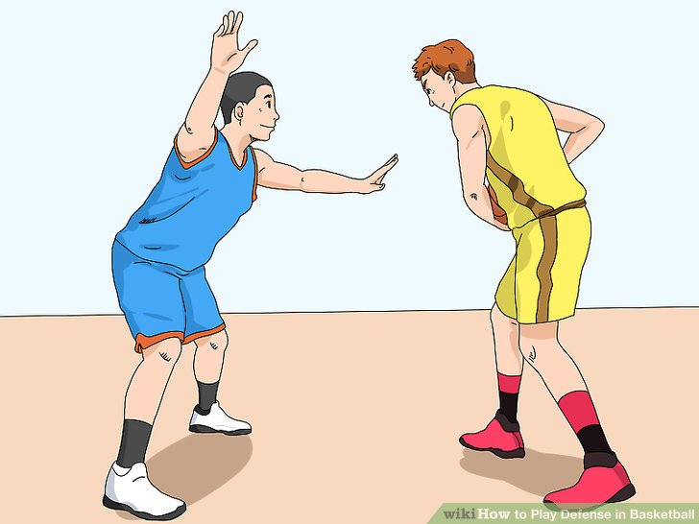

Observer _____________ Doer_______________
Cues
1 | 2 | 3
Comments for Improvement: | Comments for Improvement: | Comments for Improvement:
My partner is great at…….

Resources

Welsh, K., Durr, L., Wintle, J., & Jarvis, J. (2019, March 03). Basketball Shooting Resource Cards. Retrieved from https://www.pescholar.com/resource/basketball-shooting-resource-cards/

The UDL Guidelines. (2020, October 06). Retrieved from http://udlguidelines.cast.org/

